**ToyotaCorolla Dataset prediction Model**

Important Finding

Best model is lm(formula = Price ~ ., data = CarWorkingData[-81, ]) as it is having maximum correlation value

below is the results

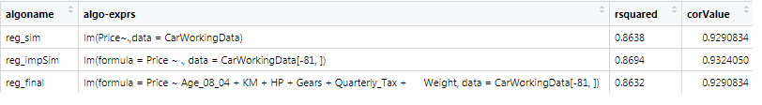

VIF value suggesting to eliminate the

vif(reg_sim)

Age_08_04 KM HP cc Doors Gears Quarterly_Tax

1.884620 1.756905 1.419422 1.163894 1.156575 1.098723 2.311431

Weight

2.516420

Highest vif value is for Weight feature 2.516420

AIC value suggesting to eliminate the cc and Doors

Step: AIC=20691.7

Price ~ Age_08_04 + KM + HP + Gears + Quarterly_Tax + Weight

Df Sum of Sq RSS AIC

<none> 2575040686 20692

- Quarterly_Tax 1 14976762 2590017448 20698

- Gears 1 17276597 2592317283 20699

- HP 1 225684613 2800725299 20810

- Weight 1 484245502 3059286188 20937

- KM 1 506728527 3081769213 20948

- Age_08_04 1 3902107988 6477148674 22014

Results are not good on those outcomes.